Pamela Ballesteros
Assignment I
Part I
- The raw MSFT monthly price data was winsorized at the 1% and 5% levels using both replacement and without replacement methods. The 1% winsorization with replacement was selected as the most appropriate approach, as it reduced the impact of extreme price observations while preserving the full monthly time series. The 5% winsorization was found to be overly aggressive, leading to greater distortion of the distribution. Trimming resulted in a reduced sample size, which is undesirable for time-series analysis and return calculations.
Version | n | mean | median | std | min | max | skew | kurtosis | p1 | p5 | p95 | p99
Raw | 180.00 | 136.43 | 71.27 | 124.92 | 23.01 | 446.95 | 0.98 | -0.36 | 24.27 | 25.81 | 406.71 | 424.90
1% cap (with replacement) | 180.00 | 136.29 | 71.27 | 124.54 | 24.27 | 424.90 | 0.97 | -0.40 | 24.44 | 25.81 | 406.71 | 423.76
1% trim (without replacement) | 176.00 | 134.29 | 71.27 | 121.51 | 24.49 | 423.46 | 0.97 | -0.38 | 24.98 | 25.95 | 391.39 | 420.92
5% cap (with replacement) | 180.00 | 135.67 | 71.27 | 123.01 | 25.81 | 406.71 | 0.94 | -0.50 | 25.81 | 25.81 | 406.37 | 406.71
5% trim (without replacement) | 162.00 | 126.72 | 71.27 | 109.36 | 25.81 | 406.35 | 0.93 | -0.48 | 25.94 | 26.67 | 335.71 | 392.55

- After selecting 1% winsorization with replacement for the MSFT monthly price series and returns were computed using the formula, the return series contains 179 observations with an average monthly return of approximately 1.70% and a standard deviation of 6.04%, indicating moderate volatility. The minimum and maximum returns are −15.5% and +19.6%, respectively, reflecting occasional large market movements. Skewness is slightly positive (0.16), while kurtosis is positive (0.43), indicating fat tails, which is typical for equity return data. A 1% winsorization of returns reduces extreme values and slightly lowers volatility, but since these extremes likely represent genuine market events, additional winsorization is not strictly required and should be applied only if needed for model stability or assumption-based methods.

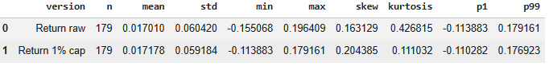

- The MSFT monthly price series is best modeled using a lognormal distribution. The fitted parameters are μ = 4.473 and σ = 0.957, where μ and σ represent the mean and standard deviation of the natural logarithm of price. For monthly returns, both Normal and Student-t distributions were fitted. The student-t distribution is more appropriate due to heavier tails in the return data and achieved a higher log-likelihood value (Student-t: 249.44 vs Normal: 248.86). The fitted Student-t parameters are df = 13.61, loc = 0.0166, and scale = 0.0557. The PDFs of the fitted distributions were plotted over the histograms of the observed data.

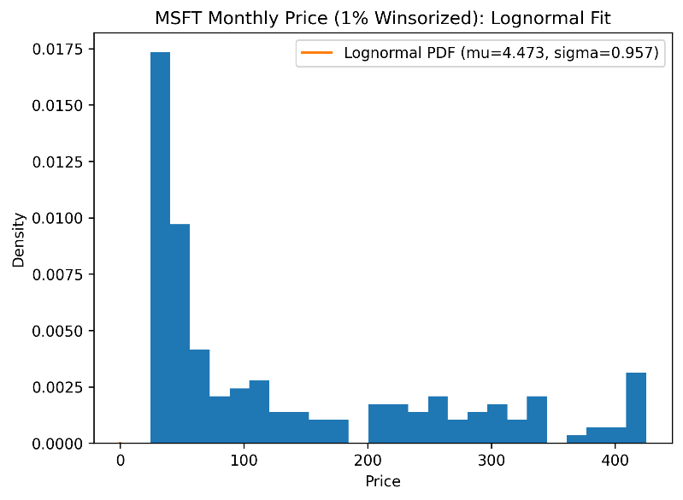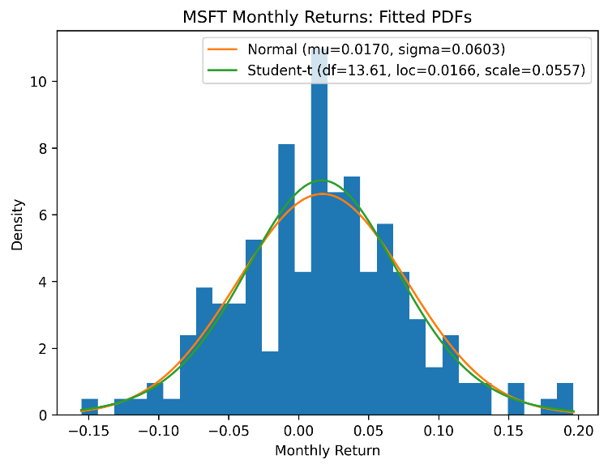
- The MSFT monthly stock price was first transformed using the natural logarithm. The logarithmic transformation is appropriate because stock prices are strictly positive and tend to be right-skewed; taking logarithms reduces skewness and often stabilizes variance. The histogram of log(price) appears approximately symmetric and bell-shaped. Therefore, a Normal distribution is appropriate for modeling the logarithm of MSFT stock price. A Normal probability density function (PDF) was fitted and plotted over the histogram of log(price), where mu (μ) and sigma (σ) represent the mean and standard deviation of the log-transformed price series. This result is consistent with the lognormal model for prices, since if price is lognormally distributed, then log(price) is normally distributed.

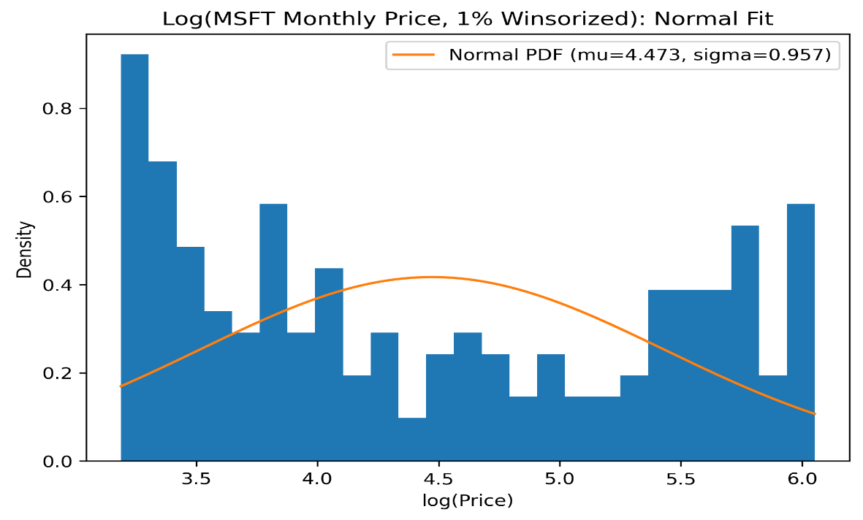
- For diagnostic, predictive, and prescriptive analytics, the return (or log-return) series is the most suitable dataset. Raw and winsorized price levels exhibit strong trends and non-stationarity, which can violate modeling assumptions, while log(price) stabilizes variance but still retains long-term trends. Returns represent percentage changes, are typically closer to stationary, and are therefore better suited for forecasting, risk analysis, and decision-oriented modeling, with winsorization serving primarily as a preprocessing step to reduce extreme-value influence.

Part II.A
- A line chart was created to visualize the adjusted closing price of Apple Inc. (AAPL) from January 2010 to December 2024. The adjusted close price was used because it accounts for stock splits and dividend adjustments. The plot highlights the long-term upward trend in Apple’s stock price as well as short-term market fluctuations across the selected period.

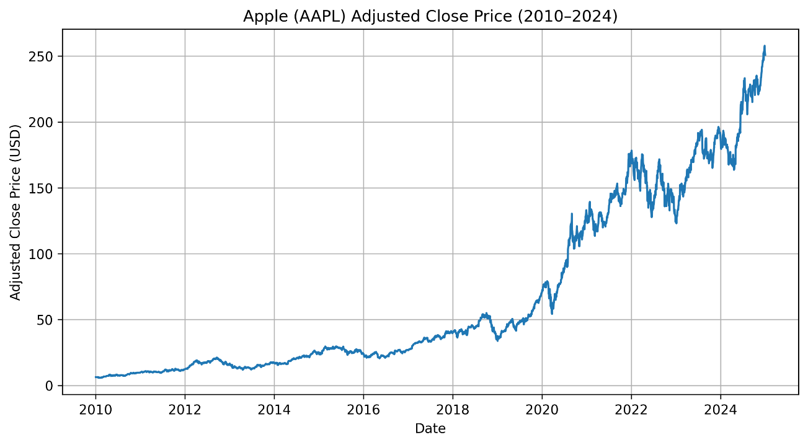

- Apple (AAPL) daily returns for August 2020, computed as percentage change in adjusted close price from one trading day to the next.

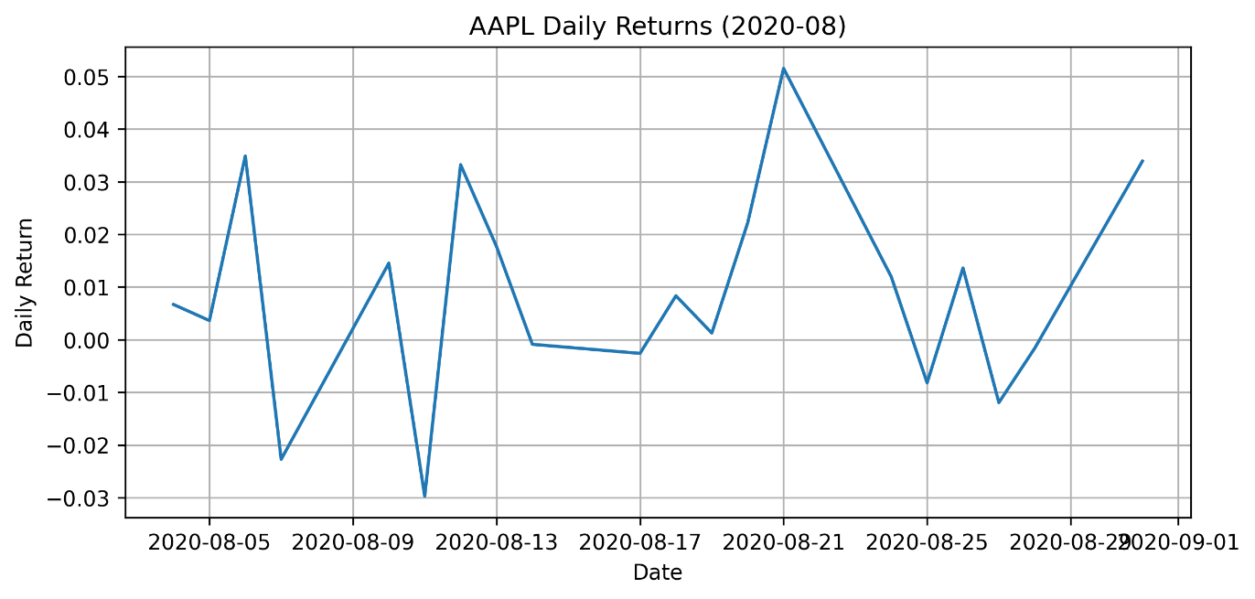

- Apple (AAPL) cumulative daily return for August 2020, computed as the cumulative product of (1 + daily return) minus 1.
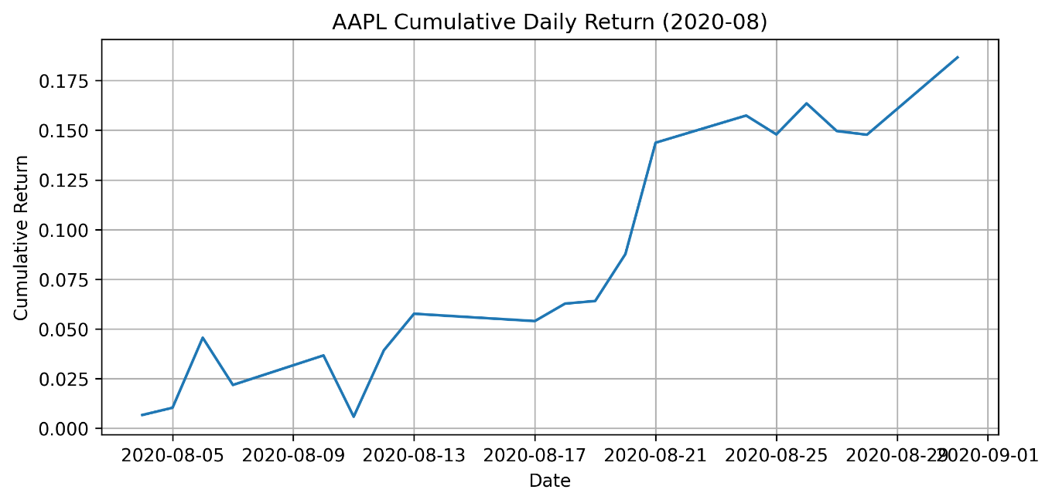

- Volatility for August 2020, measured as the standard deviation of daily returns, was 0.0201 (approximately 2.01% per day), indicating moderate day-to-day variability during the month.

- The cumulative daily return plot for August 2020 shows a strong upward trend, ending the month with an overall gain of approximately 18%. This indicates that Apple’s stock experienced sustained positive performance throughout the month. The daily return series displays noticeable fluctuations around zero, reflecting normal short-term market variability. Volatility, measured as the standard deviation of daily returns, was approximately 0.0201, corresponding to an average daily price movement of about 2.01%. This level of volatility suggests moderate market activity and increased trading intensity during the selected period.

PART II. B
A moving average crossover strategy was applied to Apple (AAPL) adjusted closing price data from January 2010 to December 2024 to identify potential buy and sell opportunities. Two rolling windows were used: a 50-day moving average to represent short-term price momentum and a 200-day moving average to represent the long-term market trend. These moving averages were calculated using rolling mean values of the adjusted close price.
A table summary below shows a Signal variable was created such that Signal = 1 when the 50-day moving average exceeded the 200-day moving average, indicating bullish momentum, and Signal = −1 when the 50-day moving average fell below the 200-day moving average, indicating bearish conditions. Buy signals (Golden Cross) were identified when the Signal changed from −1 to 1, while sell signals (Death Cross) were identified when the Signal changed from 1 to −1.
Date | Adj Close | MA50 | MA200 | Signal | Position
2012-12-10 00:00:00 | 16.0309734 | 18.01067 | 18.08008 | -1 | -2
2013-09-10 00:00:00 | 15.2534342 | 14.1929 | 14.14416 | 1 | 2
2015-08-28 00:00:00 | 25.4345055 | 27.03483 | 27.08702 | -1 | -2
2016-08-30 00:00:00 | 24.3066597 | 23.30467 | 23.29882 | 1 | 2
2018-12-21 00:00:00 | 35.8297043 | 45.73233 | 45.84009 | -1 | -2
2019-05-06 00:00:00 | 49.7698784 | 45.81888 | 45.69882 | 1 | 2
2022-06-03 00:00:00 | 142.783844 | 156.1038 | 156.2567 | -1 | -2
2022-09-26 00:00:00 | 148.283264 | 157.5153 | 157.4786 | 1 | 2
2022-10-07 00:00:00 | 137.779404 | 156.0484 | 156.1985 | -1 | -2
2023-03-22 00:00:00 | 155.721725 | 145.7078 | 145.4812 | 1 | 2
2024-03-14 00:00:00 | 171.600174 | 181.91 | 181.9654 | -1 | -2
2024-06-13 00:00:00 | 212.794708 | 181.1338 | 180.6473 | 1 | 2
Column1 | Value
Total Buy Signals | 6
Total Sell Signals | 6
Start Date | 2010-01-04 00:00:00
End Date | 2024-12-30 00:00:00

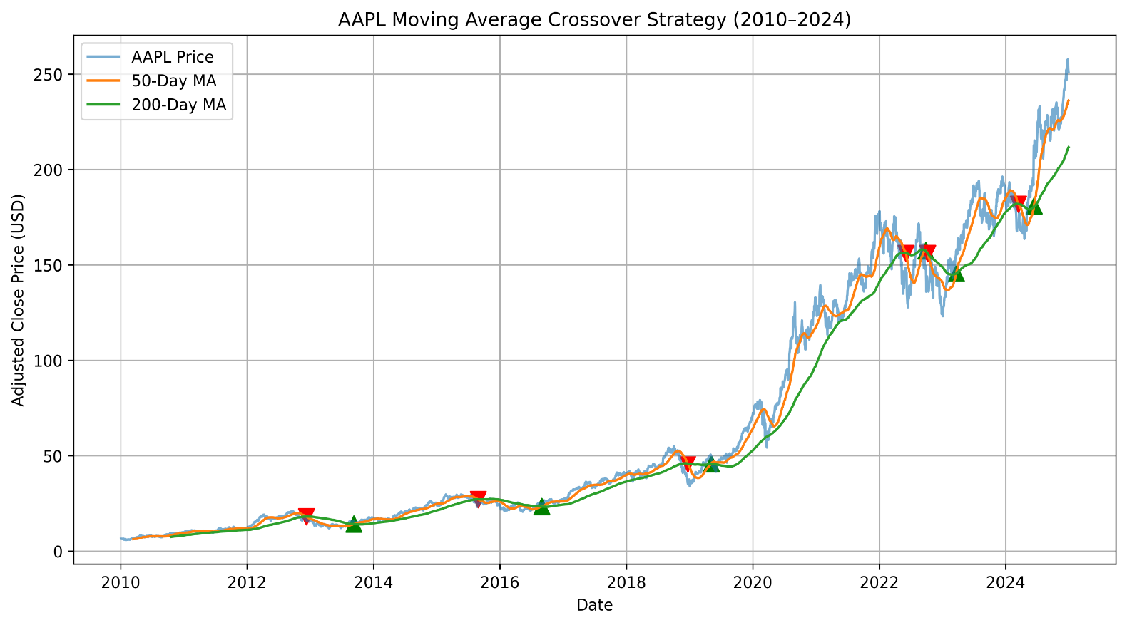
Note: Buy and Sell Signal Interpretation (Triangle Markers)
Green upward triangles (Buy signals):
- Occur when the 50-day moving average crosses above the 200-day moving average.
- This is called a Golden Cross and indicates a potential upward price trend and buying opportunity.
Red downward triangles (Sell signals):
- Occur when the 50-day moving average crosses below the 200-day moving average.
- This is called a Death Cross and signals a potential downward price trend and selling opportunity.
Purpose of the signals:
- These crossover points help identify trend reversals, momentum shifts, and possible entry and exit points in the market.
The results were visualized by plotting the adjusted price series along with both moving averages and marking buy and sell points on the chart. Over the 2010–2024 period, the strategy generated 6 buy signals and 6 sell signals, corresponding to major trend changes. The plot shows that buy signals generally align with periods of sustained upward momentum, while sell signals tend to occur near market corrections. Although the strategy exhibits some lag due to the smoothing nature of moving averages, it effectively identifies long-term trend shifts and potential trading opportunities.

Part III A. AI- Generated Analysis (Replication and Extension)
For this part, I used AI as an analytical support tool to assist with data processing, visualization, and interpretation of Microsoft (MSFT) and Apple (AAPL) stock data. The goal was not to replace initial assessment, but to accelerate repetitive computations, improve visualization quality, and support interpretation of financial patterns.
The AI was used as a computational assistant and interpretation aid, while I remained responsible for defining analysis requirements, validating outputs, and structuring the final report.
Summary of Prompts Used

Rather than using a single prompt, sequence of structured instructions was used to guide and prompt the AI. These prompts can be summarized as follows:
- Requested descriptive and diagnostic analysis of MSFT stock prices and returns, including outlier detection, winsorization, distribution testing, and transformations.

- Asked for visualization and analysis of AAPL stock prices and returns, including rolling volatility estimation, which AI pulled the data from Stooq.

- Requested implementation of a simple 50-day and 200-day moving average crossover trading strategy for AAPL.

- Asked the AI to interpret results in financial terms rather than only producing numerical outputs.

These prompts were iterative and refined based on intermediate outputs and assignment requirements.

Tasks Delegated to AI

The following technical and computational tasks were delegated to AI:
- Data Processing and Cleaning – after MSFT dataset was uploaded, it performed the computation of price transformations (log prices), calculated monthly and daily returns and identified extreme return values and application of winsorization.
- Statistical and Diagnostic Analysis – it performed the computation of descriptive statics for prices and returns. It evaluated distributional characteristics such as skewness, kurtosis and normality indicators and estimating rolling volatility for Apple stock.
- Visualization – it generated time-series plots of prices and log prices, created return series plots, produced volatility charts and visualizations of the moving average crossover signals.
- Trading Strategy Implementation – it implemented a 50-day and 200-day moving average crossover strategy for Apple. Computed performance metrics including annualized return, volatility and maximum drawdown.
Outputs Generated by AI
- Summary Tables – it produced descriptive statistics for both MSFT and AAPL prices and returns, outlier identification tables for MSFT returns and performance metrics for buy-and-hold and moving average strategy results.
- Visual Outputs – MSFT price, log-price, and return distribution plots were produced. Return charts, stock price, rolling volatility visualization for Apple. It also produced the Moving average crossover signal plot and strategy equity curve for Apple.
- Quantitative Results – extreme MSFT monthly return observations were determined, changes in volatility estimates after winsorization, and strategy performance metrics including compound annual growth rate, volatility and drawdown.
Part B. Benchmarking AI against own analysis
- The AI performed particularly well in terms of speed and systematic execution, rapidly computing returns, rolling volatility, log transformations, and moving average indicators that would have required significantly more manual effort. It applied consistent analytical steps across both MSFT and AAPL, reducing calculation errors and improving workflow efficiency. It also explained the trade-off between return and risk in the moving average crossover strategy, strengthening the interpretation of technical trading limitations. Finally, the AI produced high-quality visualizations and summary tables that improved clarity, supported interpretation, and made performance comparisons more intuitive.
- The AI occasionally oversimplified financial assumptions by treating the moving average strategy as frictionless, ignoring transaction costs, and liquidity constraints that would reduce real - world performance. It also relied on approximate assumptions without fully emphasizing fat tails and extreme downside risk in financial returns. In some cases, the AI generalized volatility behavior across time periods without sufficiently distinguishing between structural market regimes. Additionally, the AI did not fully account for dataset limitations, including differences in frequency and sourcing between MSFT and AAPL data which required manual review or verification.
- I accepted the AI’s insights regarding volatility clustering because it was clearly supported by rolling volatility patterns observed in Apple return series. I also accepted the recommendation to analyze returns rather than prices, as this is consistent with statistical best practices and improved the modeling. The AI’s interpretation of the risk-return trade-off in moving strategy was also accepted because metrics showed reduced volatility but lower long-term returns relative to buy-and-hold.
- I rejected the implied suggestion that the moving average crossover strategy provides meaningful downside protection because the empirical drawdown results showed risk exposure comparable to the buy-and-hold benchmark, making this conclusion inconsistent with observed performance. I also discarded simplified assumptions about frictionless trading and perfect execution, which reflect weak economic intuition given the presence of transaction costs, slippage, and liquidity constrains in real market. I also rejected interpretations that implicitly assumed stable return distributions, as financial data exhibit fat tails and volatility clustering that violate these assumptions. These rejections were necessary to prevent overstating strategy robustness and predictive reliability.
Part C. Impact on the Final Assessment
- The AI refined my understanding of return distributions by reinforcing that financial returns exhibit volatility clustering and non-normal behavior, which strengthened my focus on regime-dependent risk rather than relying on constant volatility assumptions. It also increased my confidence in using log prices, returns, and winsorization, as these techniques improved statistical stability and reduced the influence of extreme observations without distorting long-term trends. However, the AI did not change my perception of simple technical trading rules, since the moving average crossover strategy continued to demonstrate limited downside protection and weaker long-term performance compared to buy-and-hold investing.
- My assessment changed primarily in how I interpret short-term risk behavior rather than overall investment performance. The AI’s rolling volatility analysis made me place greater emphasis on time-varying risk and market regime shifts, particularly during periods of heightened uncertainty. This improved my ability to evaluate dynamic risk exposure while maintaining the same conclusions about long-term return trends.
- My original analysis remains valid because it was grounded in empirical evidence and financial theory, particularly regarding the limitations of technical trading strategies and the importance of long-term trend behavior. Although the AI improved computational efficiency and visualization quality, it did not introduce new evidence that contradicted my initial findings. The consistency between my manual analysis and AI-generated results confirms that sound financial reasoning and data-driven validation remain more reliable than automated output alone.
Part D. Reflection on AI as an analytics tool
- AI enhances financial analytics when performing repetitive computations, large-scale data processing, and visualization tasks such as calculating returns, volatility measures, and technical indicators. In this assignment, AI improved efficiency and consistency while allowing greater focus on interpretation rather than manual calculation.
- AI requires human judgment when validating assumptions, interpreting strategy performance, and accounting for real-world constraints such as transaction costs, market frictions, and changing risk regimes. Domain knowledge is necessary to ensure that outputs remain economically meaningful and analytically consistent.
- Going forward, I would use AI as a technical support tool for data preparation, computation, and visualization, while retaining responsibility for modeling decisions and financial interpretation. This approach preserves analytical consistency and accuracy while benefiting from automation efficiency.

